**A PRELIMINARY REPORT ON**

**LIVE STOCK MONITORING AND HEALTH CARE**

SUBMITTED TO THE VISHWAKARMA INSTITUTE OF INFORMATION TECHNOLOGY, PUNE

IN THE PARTIAL FULFILLMENT OF THE REQUIREMENTS

FOR THE AWARD OF THE DEGREE

OF

**BACHELOR OF TECHNOLOGY (COMPUTER ENGINEERING)**

##### **SUBMITTED BY**

STUDENT NAME : **SUJITKUMAR SANJAY PATIL**

PRN No. : **22010360**

STUDENT NAME : **KIRAN RAJARAM MUSALE**

PRN No. : **22010449**

STUDENT NAME : **SURAJ ASHOK MESHARAM**

PRnt No. : **22010815**

STUDENT NAME : **SANSKRUTI ANIL JAISWAL**

PRNt No. : **22010690**



## **DEPARTMENT OF COMPUTER ENGINEERING**

**BRACT’S**

**VISHWAKARMA INSTITUTE OF INFORMATION TECHNOLOGY**

SURVEY NO. 3/4, KONDHWA (BUDRUK), PUNE – 411048, MAHARASHTRA (INDIA).

**BRACT’S**

**VISHWAKARMA INSTITUTE OF INFORMATION TECHNOLOGY, PUNE**

## **2023 - 2024**



**CERTIFICATE**

This is to certify that the project report entitled

**LIVE STOCK MONITORING AND HEALTH CARE**

##### **SUBMITTED BY**

| **STUDENT NAME** | **Gr. No.** | **Roll. No.** |
| --- | --- | --- |
| Sanskruti Jaiswal | 22010690 | 422013 |
| Sujitkumar Patil | 22010360 | 422026 |
| Suraj Meshram | 22010815 | 422018 |
| Kiran Musale | 22010449 | 422015 |

is a bonafide student of this institute and the work has been carried out by him under the supervision of **Prof. Madhuri Karnik** and it is approved for the partial fulfillment of the requirement of VISHWAKARMA INSTITUTE OF INFORMATION TECHNOLOGY, for the award of the degree of **Bachelor of Technology** (Computer Engineering).

(Prof. Madhuri Karnik) (Dr. S. R. Sakhare)

Guide Head,

Department of Computer Engineering Department of Computer Engineering

(Dr. Vivek Deshpande)

Director,

BRACT’s Vishwakarma Institute of Information Technology, Pune-48

Place : Pune

Date :

**ACKNOWLEDGEMENT**

The project work in our academic course is prescribed to develop our skills, ability and confidence level. It is a matter of pride to have the privilege of report assignment, presentation and so on. Every project big or small is successful largely due to the effort of a number of wonderful people who have always given their valuable advice or lent a helping hand. Expression of thanks adequately carries deep feelings of thankfulness for help, advice and encouragement given by our facilitators and who directly as well as indirectly assisted in preparing this assignment.  
  
 We sincerely appreciate the inspiration, support and guidance of all those people who have been instrumental in making this assignment a success. We entire members of Group 13 are extremely grateful to Madhuri Karnik Mam and Disha Wankhede Mam for conscientious guidance and encouragement to accomplish this project.

Our thanks and appreciation also go to our ISP provider for their internet service, our family members for their cooperation, advice, help and support, our friends who directly or indirectly assisted me to complete this project report and to all those who knowingly and unknowingly helped in preparing this assignment.

Thank You!

**ABSTRACT**

With the continual advancement of technology, the application domains of websites are expanding rapidly. Across various sectors, there is a growing demand for swift, accurate, and automated operations. To meet these diverse needs, different programs are being developed to cater to users across various fields.

One notable area of technological innovation is Precision Livestock Farming (PLF) and Animal Welfare Monitoring, which are revolutionizing the livestock industry by prioritizing the well-being of individual animals. This paradigm shift is driven by a commitment to leveraging cutting-edge technologies for more humane and efficient practices in animal care.

The integration of Internet of Things (IoT) technology into animal health monitoring stands out as a transformative solution within the veterinary care domain. This paper introduces a Smart Animal Health Monitoring System (SAHMS) that harnesses the capabilities of IoT to elevate the management of both livestock and companion animals. By employing IoT, the system ensures a continuous and real-time monitoring approach, providing unprecedented insights into the health status of each monitored animal.

The proposed system's advantages extend beyond merely early disease detection. It incorporates automated alerts and notifications, promptly informing animal caregivers of abnormal health conditions. This feature empowers caregivers to take immediate and informed action, thereby enhancing the overall health management of the animals. Furthermore, the system facilitates remote access to animal health data for veterinarians, enabling telemedicine consultations. This not only streamlines veterinary care but also allows for timely interventions based on comprehensive, up-to-date information, ultimately contributing to improved animal well-being and healthcare outcomes. The intersection of IoT and animal health monitoring is poised to redefine standards in veterinary practices, ensuring a more proactive and responsive approach to animal care.

**TABLE OF CONTENTS**

| **Sr. No.** | | | | **Title of Chapter** | | | **Page No.** |
| --- | --- | --- | --- | --- | --- | --- | --- |
| **01** | | | | **Introduction** | | | 10 |
|  | 1.1 | | | Overview | | | 10 |
|  | 1.2 | | | Motivation | | | 11 |
|  | 1.3 | | | Problem Definition and Objectives | | | 13 |
|  | 1.4 | | | Project Scope & Limitations | | | 14 |
| **02** | | | | **System Overview** | | | 18 |
| **03** | | | | **Software Requirements Specification** | | | 20 |
|  | | 3.1 | | Assumptions and Dependencies | | | 20 |
|  | | 3.2 | | Functional Requirements | | | 23 |
|  | |  | | 3.2.1 | | LM35 | 23 |
|  | |  | | 3.2.2 | | Pulse Heart Rate | 24 |
|  | |  | | 3.2.3 | | 3D Accelerometer | 25 |
|  | |  | | 3.2.4 | | Esp32 Wroom WiFi Module | 27 |
|  | | 3.3 | | Nonfunctional Requirements | | | 30 |
|  | |  | | 3.3.1 | | Reliability | 31 |
|  | |  | | 3.3.2 | | Performance | 31 |
|  | |  | | 3.3.3 | | Scalability | 32 |
|  | |  | | 3.3.4 | | Security | 32 |
| **04** | | | | **System Design** | | | 36 |
|  | | 4.1 | | System Architecture | | | 36 |
|  | | 4.2 | | Data Flow Diagrams | | | 37 |
|  | | 4.3 | | Sequence Diagram | | | 38 |
|  | | 4.4 | | Entity Relationship Diagrams | | | 38 |
|  | | 4.5 | | UML Diagrams | | | 39 |
| **05** | | | | **Project Plan** | | | 40 |
|  | | | 5.1 | Project Estimate | | | 40 |
|  | | |  | 5.1.1 | Reconciled Estimates | | 40 |
|  | | |  | 5.1.2 | Project Resources | | 41 |
|  | | | 5.2 | Risk Management | | | 43 |
|  | | |  | 5.2.1 | Risk Identification | | 43 |
|  | | |  | 5.2.2 | Risk Analysis | | 44 |
|  | | |  | 5.2.3 | Overview of Risk Mitigation, Monitoring, Management | | 45 |
|  | | | 5.3 | Project Schedule | | | 47 |
|  | | |  | 5.3.1 | Project Task Set | | 47 |
|  | | |  | 5.3.2 | Task Network | | 49 |
|  | | |  | 5.3.3 | Timeline Chart | | 50 |
|  | | | 5.4 | Team Organization | | | 50 |
|  | | |  | 5.4.1 | Team structure | | 50 |
|  | | |  | 5.4.2 | Management reporting and communication | | 50 |
| **06** | | | | **Project Implementation** | | | 51 |
| **07** | | | | **Results** | | | 54 |
|  | | | 7.1 | Outcomes/Screenshots | | | 54 |
| **08** | | | | **Conclusions** | | | 57 |
|  | | 8.1 | | Conclusions | | | 57 |
|  | | 8.2 | | Future Work | | | 59 |
|  | | 8.3 | | References | | | 61 |

1. **INTRODUCTION**

**1.1. OVERVIEW**

Precision Livestock Farming (PLF) and Animal Welfare Monitoring are innovative approaches that aim to revolutionize the livestock industry by focusing on the well-being of individual animals.Unlike traditional methods, these systems eliminate the need for manual data collection by employing Internet of Things (IoT) technology, thereby overcoming the challenges of time-consuming and labor-intensive practices.

Key components of the proposed monitoring system include temperature sensors, heart rate sensors, activity sensors, and a microcontroller module such as the Arduino Uno. These sensors are strategically attached to the animal, continuously collecting data on its health parameters. The benefits of employing IoT technology in animal health monitoring extend beyond the convenience of continuous and remote data collection. The system excels in detecting subtle changes in an animal's health parameters that might escape human observation.

In summary, while the use of IoT technology in animal health monitoring holds great promise for revolutionizing animal care practices, it is essential to address concerns over data privacy and security. By overcoming these challenges, we can unlock the full potential of advanced monitoring systems, leading to improved animal welfare, more effective disease management, and overall advancements in the field of animal care and agriculture.

**Targeted Species –**

1] Cattle – cow, buffalo

2] Pet animal - dog and cat

**1.2. MOTIVATION**

The motivation behind developing an IoT-based animal health monitoring system stems from the growing recognition of the crucial role animals play in various sectors, including agriculture, research, and companion animals. Ensuring the well-being of animals is not only a moral imperative but also essential for optimizing productivity, maintaining biodiversity, and fostering sustainable practices. Traditional methods of monitoring animal health often fall short in providing real-time, comprehensive insights into their physiological conditions.

By integrating IoT technologies into animal health monitoring, we aim to revolutionize the way we care for animals. This system allows for continuous, remote monitoring of vital parameters such as heart rate, temperature, and activity levels, providing early detection of health issues and enabling prompt intervention. The real-time data generated by the IoT devices can be analyzed through advanced analytics and machine learning algorithms, offering actionable insights that empower veterinarians, farmers, and researchers to make informed decisions. Ultimately, the IoT-based animal health monitoring system aligns with a broader vision of advancing animal welfare, improving resource efficiency, and fostering a more sustainable and compassionate approach to animal management.

**Enhanced Animal Well-being:**By implementing IoT-driven monitoring, we are contributing to the well-being of individual animals. our efforts directly translate into improved living conditions, timely healthcare, and a better quality of life for the livestock.

**Revolutionizing Agriculture:** our work has the potential to revolutionize traditional farming practices. Through the integration of technology, we will be at the forefront of shaping a more efficient, sustainable, and humane approach to agriculture.

**Early Disease Detection:**The ability to detect subtle changes in health parameters ensures early disease detection. Your work can prevent the spread of illnesses, saving both individual animals and entire herds from potential health crises.

**Precision and Productivity:**Precision in monitoring leads to precision in farming. Your contributions pave the way for more productive and sustainable agriculture, aligning with the global need to feed a growing population.

**Tech-Driven Solutions:**our involvement in leveraging IoT technology showcases the power of innovation in addressing age-old challenges. You're not just adopting technology; you're actively creating solutions that can redefine the future of animal care and agriculture.

**1.3.A PROBLEM DEFINITION**

The current state of animal health monitoring relies heavily on periodic and manual assessments, leading to potential delays in identifying health issues and providing timely intervention. Additionally, the lack of continuous monitoring systems results in a limited understanding of an animal's well-being, hindering the ability to proactively address emerging health concerns. To overcome these challenges, there is a need for an advanced and automated solution that leverages IoT technologies to continuously track key physiological parameters such as motion, temperature, and heart rate in animals. This system aims to provide real-time, comprehensive data for more accurate and timely health assessments, thereby enhancing the overall welfare of animals in various settings.

**1.3.B OBJECTIVES**

* **Continuous Monitoring:** Develop a robust IoT-based system capable of continuously monitoring and recording the motion, temperature, and heart rate of animals in a non-intrusive manner. This continuous data stream will provide a more comprehensive understanding of an animal's behavior and health status.
* **Data Analysis and Interpretation:** Implement advanced analytics and machine learning algorithms to analyze the collected data. The objective is to derive meaningful insights from the sensor data, identifying patterns and anomalies that may indicate changes in the animal's health. This analysis will contribute to early detection of health issues and enable proactive intervention.
* **Real-time Alerts and Reporting:** Establish a mechanism for real-time alerts and reporting based on the analyzed data. This ensures that relevant stakeholders, such as farmers or veterinarians, are promptly informed of any concerning changes in the animal's health parameters, allowing for immediate action and preventive measures.
* **User-Friendly Interface:** Design an intuitive and user-friendly interface for end-users, enabling easy access to the monitored data, alerts, and historical trends. The interface should be adaptable to different user needs, such as farmers, veterinarians, or researchers, facilitating effective decision-making and care management.

**1.4.A PROJECT SCOPE**

* **Multi-Parameter Monitoring:** The project will encompass the development of a comprehensive system capable of monitoring multiple parameters, including motion, temperature, and heart rate, to provide a holistic view of the animal's health.
* **Sensor Integration:** Integration of IoT sensors and devices into the monitoring system to capture real-time data. These sensors should be chosen and calibrated to ensure accuracy and reliability in various environmental conditions.
* **Data Transmission and Storage:** Design a secure and efficient data transmission mechanism to relay information from sensors to a centralized system. Implement a robust storage solution to store and manage the vast amount of data generated by continuous monitoring.
* **Analytics and Machine Learning Implementation:** Develop and implement advanced analytics and machine learning algorithms to analyze the collected data. This includes pattern recognition, anomaly detection, and health status prediction based on historical trends.
* **Real-Time Alerts:** Implement a real-time alert system to notify stakeholders of any deviations from normal health parameters. The alerts should be customizable and capable of reaching end-users through various communication channels.
* **User Interface:** Design an intuitive and user-friendly interface accessible through web or mobile applications. The interface should provide real-time and historical data visualization, customizable reporting, and easy navigation for different user roles.

**1.4.B LIMITATIONS**

* **Battery Life:** The reliance on IoT sensors may be constrained by battery life. Addressing limitations in battery technology and optimizing power consumption will be a key consideration.
* **Sensor Accuracy:** The accuracy of sensor readings may be influenced by factors such as sensor calibration, environmental conditions, and animal behavior. Ongoing calibration and quality control measures will be implemented to mitigate inaccuracies.
* **Data Security and Privacy:** Ensuring the security and privacy of sensitive data is paramount. Implement robust encryption protocols and access controls to protect the integrity and confidentiality of the collected information.
* **Cost Constraints:** The project scope may be limited by budget constraints, impacting the selection of sensors, communication protocols, and overall system complexity. Balancing cost-effectiveness with system performance will be a critical consideration.
* **Environmental Factors:** External environmental factors, such as extreme weather conditions or physical damage to sensors, may affect the system's functionality. The project will need to consider protective measures and resilience to environmental challenges.
* **Species-Specific Considerations:** While the system aims for scalability, there may be species-specific variations in health monitoring requirements. The project will focus on adaptability but may have limitations in addressing the unique needs of every animal species.
* **Regulatory Compliance:** Adherence to local and international regulations related to animal welfare and data privacy will be a constraint. The system design should ensure compliance with relevant standards and guidelines.

1. **SYSTEM OVERVIEW**

**Monitoring Livestock Health and Behavior**

The proposed model is intended to be helpful for all pet owners and doctors who can closely monitor animal health activities.

This is achieved through the use of various sensors, cameras, and environmental monitors, which provide real-time data on factors such as body temperature, heart rate, movement patterns, and living conditions.

There are several technologies and methods available for this purpose:

**Visual Observation:** Regular visual checks by experienced animal caregivers are a fundamental method for monitoring livestock health and behavior. Look for signs of illness or injury, changes in behavior, or abnormalities in physical appearance.

**Animal ID and Tagging**: Assigning unique identification numbers or RFID tags to individual animals allows for tracking and monitoring their health and behavior over time.

**Veterinary Examination**: Regular veterinary check-ups and assessments are crucial for identifying and treating health issues in livestock.

**Temperature Monitoring**: Use thermometers to monitor the body temperature of livestock. Elevated body temperature can be an early sign of illness.

**Activity Monitors:** Wearable devices or ear tags equipped with accelerometers can track the activity levels of animals. Changes in activity patterns can indicate health problems.

**GPS Tracking**: In extensive grazing systems, GPS trackers can help monitor the location and movement patterns of livestock, ensuring they are where they are supposed to be.

**Health Sensors**: Various sensors can be deployed in the barn or pasture to monitor environmental conditions, such as temperature, humidity, and air quality. These factors can impact livestock health.

**Livestock Behavior Cameras**: Set up cameras in barns or pastures to observe animal behavior remotely. This can help identify abnormal behavior or signs of distress.

**Weight Scales**: Regularly weigh livestock to track their growth and identify weight loss, which could be a sign of health problems.

**Feed and Water Monitoring:** Monitor feed and water consumption to ensure that animals are eating and drinking as expected. Changes in consumption can be an early indicator of illness.

**Sound Analysis:** Some systems use microphones to analyze the sounds made by livestock. Changes in vocalizations can provide insights into their well-being.

**Blood and Urine Tests:** Periodic blood and urine tests can provide valuable information about the health of individual animals.

1. **SOFTWARE REQUIREMENT AND SPECIFICATION**

**3.1. ASSUMPTIONS AND DEPENDENCIES**

When developing an IoT-based animal health monitoring system, it's important to consider certain assumptions and dependencies. These help in setting expectations, guiding the development process, and ensuring a more realistic and effective implementation. Here are some assumptions and dependencies for the proposed problem statement:

**ASSUMPTIONS:**

* **Sensor Accuracy and Reliability:**
* It is assumed that the sensors integrated into the monitoring devices are accurate and reliable in capturing motion, temperature, and heart rate data. Regular calibration and quality checks are anticipated to maintain the precision of these sensors.
* **Wireless Connectivity:**
* The assumption is made that the wireless communication infrastructure, which facilitates data transmission from the monitoring devices to the central system, is robust and reliable. Factors such as signal strength and network stability are considered to support seamless connectivity.
* **Animal Adaptation:**
* It is assumed that the animals adapt well to wearing the monitoring devices as neckbands. The assumption includes the comfort and non-invasiveness of the devices, allowing animals to behave naturally without undue stress or discomfort.
* Power Management: The assumption is that the power management system within the monitoring devices effectively conserves battery life. This includes the ability to provide long-lasting battery performance without frequent replacements, ensuring continuous monitoring.
* **User Training and Adoption:**
* It is assumed that users, including farmers, veterinarians, and caregivers, receive adequate training to use the monitoring system effectively. User adoption is expected to be facilitated through intuitive interfaces and clear documentation.

**DEPENDENCIES:**

* **Sensor Technology Development:**
* The successful implementation of the monitoring system is dependent on advancements in sensor technology. Progress in sensor accuracy, miniaturization, and energy efficiency can significantly impact the capabilities and performance of the monitoring devices.
* **IoT Infrastructure Stability**:
* The stability and reliability of the IoT infrastructure, including cloud services or on-premise servers, are crucial dependencies. Any disruptions in these services may affect the real-time data transmission and processing capabilities of the system.
* **Regulatory Compliance:**
* The system's deployment is dependent on compliance with animal welfare regulations and data protection laws. Changes in these regulations may necessitate adjustments to the system to ensure continued adherence.
* **Integration with Existing Systems:**
* The successful integration of the monitoring system with existing farm management systems or databases is a dependency. Compatibility with diverse systems may require collaboration and coordination with external stakeholders or technology providers.
* **Technological Standards:**
* Dependencies exist on technological standards and protocols, especially in the realm of IoT communication. Adherence to established standards ensures interoperability and compatibility with various devices and platforms.
* **Weather Conditions**:
* The system's functionality may be influenced by environmental factors, particularly weather conditions. Extreme weather events or harsh environments may impact the devices' performance, and the system design should consider these dependencies.

Understanding and managing these assumptions and dependencies will contribute to a more informed and realistic development and deployment of the IoT-based animal health monitoring system. Regular monitoring and adaptation to changes in technology, regulations, and environmental conditions will be crucial for the system's long-term success.

**3.2. FUNCTIONAL REQUIREMENTS**

**1] LM35 Temperature Sensor-**

The LM35 temperature sensor is a widely used analog temperature sensor that can play a crucial role in monitoring livestock health and behavior.

**Detecting Fever or Illness:**

The LM35 temperature sensor can be placed on or inside the livestock to continuously monitor body temperature.

Elevated body temperature could indicate fever or illness, prompting further investigation and potential veterinary intervention.

**Early Disease Detection:**

Sudden spikes in body temperature recorded by the LM35 sensor may indicate the early onset of diseases or infections.

Early detection allows for timely treatment, potentially preventing the disease from spreading to other animals.

**Monitoring Ambient Temperature:**

The LM35 sensor can also be placed in the animal's environment, such as barns or pastures, to monitor the ambient temperature.

Extreme temperatures can stress livestock, affecting their behavior, feed consumption, and overall health. Continuous monitoring helps ensure a comfortable environment.

**Cost - 100/-**

**2] Pulse Heart Rate Sensor**

Incorporating a Pulse Heart Rate Sensor in monitoring livestock health and behavior can provide crucial insights into the well-being of the animals.

Assessing Stress Levels:

Measuring the heart rate of livestock using a pulse heart rate sensor can help assess stress levels.

An elevated heart rate may indicate stress, which could be due to various factors such as transportation, changes in environment, or health issues.

An abnormal heart rate, especially if it's consistently high, might indicate pain or discomfort in the animal.

**Cost - 250/-**

**3] 3D Accelerometer**

Integrating a 3D accelerometer in monitoring livestock health and behavior offers a comprehensive approach to understanding their movements, activities, and overall well-being.

A 3D accelerometer can measure the intensity and frequency of movements, providing insights into the activity levels of livestock.

Tracking physical activity helps in assessing the overall health and well-being of the animals. Changes in activity patterns could indicate potential health issues or discomfort.

A 3D accelerometer is a sensor that measures acceleration along three perpendicular axes: X, Y, and Z. Acceleration is the rate of change of velocity with respect to time, and it is typically measured in units like meters per second squared (m/s²) or gravitational units (g). The "3D" in 3D accelerometer refers to the three-dimensional space in which it can measure acceleration.

Here are some key points about 3D accelerometers:

**Triaxial Measurement:**

A 3D accelerometer provides three independent measurements of acceleration, corresponding to the three spatial dimensions. These sensors can detect changes in acceleration along the X-axis, Y-axis, and Z-axis.

**Microelectromechanical Systems (MEMS) Technology:**

Many modern 3D accelerometers use MEMS technology, where tiny silicon structures are employed to measure acceleration. MEMS accelerometers are compact, lightweight, and can be integrated into a variety of devices, including smartphones, wearable devices, drones, and more.

**Applications:**

**Consumer Electronics:** In smartphones and tablets, accelerometers are used for screen orientation, step counting, gaming, and gesture recognition.

**Automotive:** Accelerometers are used in vehicle stability control systems, airbag deployment, and anti-lock braking systems.

**Health and Fitness:** Wearable devices often use accelerometers to track physical activity, monitor sleep patterns, and estimate calorie expenditure.

**Navigation:** Inertial navigation systems use accelerometers to determine changes in velocity and position.

Industrial Applications: Accelerometers are used for monitoring vibrations in machinery and structures to detect faults or assess structural health.

**Output:** The output of a 3D accelerometer is typically in the form of electrical signals that represent acceleration along each axis. These signals can be processed by a microcontroller or other electronics to derive information about the device's movement or orientation.

**Sensor Fusion:** In some applications, 3D accelerometers are used in conjunction with other sensors like gyros and magnetometers for sensor fusion. This helps provide a more complete picture of the device's motion and orientation.

**Cost - 150/**

**4] ESP32 Wroom WiFi-Bluetooth Module**

Powerful Wi-Fi+Bluetooth/Bluetooth LE modules that target a wide variety of AIoT applications, ranging from low-power sensor networks to the most demanding tasks.

### **Wi-Fi & Bluetooth Dual Mode**

The integration of Wi-Fi, Bluetooth and Bluetooth LE ensures that a wide range of applications can be targeted, and that our modules are truly versatile. Using Wi-Fi ensures connectivity within a large radius, while using Bluetooth allows the user to easily detect a module (with low-energy beacons), and connect it to a smartphone.

### **High Integration**

With in-built antenna switches, RF balun, power amplifier, low-noise receive amplifier, filters, and power management modules, our chips add priceless functionality and versatility to your applications with minimal PCB requirements.

### **Configurability and Customization**

ESP32 modules can be ordered with different antenna configurations (e.g. PCB antenna, antenna connector) and flash sizes, so that they correspond to the needs of different applications. ESP32 modules also offer manufacturing customizations with pre-programmed application firmware, custom data and pre-provisioned cloud certificates.

### **Application-Ready**

All ESP32 Series of modules have a wide operating temperature range of -40°C to 105°C, and are suitable for commercial application development with a robust 4-layer design that is fully compliant with FCC, CE-RED, SRRC, IC, KCC & TELEC standards.

**Cost - 400/-**

**5] Bread Board:**

A breadboard, also known as a protoboard or solderless breadboard, is a fundamental tool in electronics prototyping and experimentation. It is a rectangular board with a grid of holes into which electronic components can be inserted to create temporary circuits without the need for soldering. The design of a breadboard allows for quick and easy assembly, modification, and disassembly of circuits, making it an essential tool for hobbyists, students, and professionals working on electronic projects.

Here are some key features and components of a typical breadboard:

* **Holes and Rows:** The board is divided into columns and rows of interconnected holes. Components can be plugged into these holes, and the rows and columns provide a convenient way to connect various elements of a circuit.
* **Power Rails:** There are typically two sets of long rows running parallel to the shorter sides of the board, known as power rails. One rail is for connecting to the positive voltage (Vcc), and the other is for connecting to the ground (GND). These rails are used to distribute power to different parts of the circuit.
* **Terminal Strips:** The holes in the terminal strips (the main body of the board) are internally connected in groups of five, making it easy to create circuits and connect components. The gaps in the middle of the board separate the terminal strips into two halves, allowing for the creation of dual-row circuits.
* **Binding Posts:** Some breadboards have binding posts for external power connections. These can be useful for connecting power sources or test equipment to the circuit.
* **Bus Strips:** In addition to the main terminal strips, there are often bus strips on the sides of the board, allowing for more extensive connections.
* **Notches and Mounting Holes:** Breadboards often have notches on the sides, allowing multiple boards to be connected for larger projects. Mounting holes are also present to secure the breadboard to a surface.

**Cost : 80-100/-**

**3.3. NON-FUNCTIONAL REQUIREMENTS**

Non-functional requirements in the context of the IoT-based animal health monitoring system refer to aspects of the system that are not directly related to its specific functionalities but are crucial for its overall performance, usability, and compliance. Here are some non-functional requirements for the animal health monitoring system:

**3.3.a. Reliability:**

Reliability goes beyond just ensuring the system is available. It encompasses the system's ability to consistently deliver accurate and trustworthy results. For the animal health monitoring system, this means not only being operational but also maintaining the precision of sensor data over time. The system should include mechanisms for periodic calibration and verification of sensor accuracy. Additionally, proactive monitoring of the system's health, with automated alerts for potential issues, can contribute to a more reliable and resilient system.

**3.3.b. Performance:**

In terms of performance, a nuanced consideration involves optimizing the system for minimal latency. Achieving low response times is not only about quickly fetching and presenting data but also about real-time analytics. The system should be capable of processing the high-frequency sensor data swiftly, providing meaningful insights to users almost instantaneously. Continuous performance monitoring and optimization based on usage patterns and data load can ensure that the system consistently meets or exceeds performance expectations.

**3.3.c. Scalability:**

Scalability isn't just a matter of handling more animals. It involves gracefully accommodating growth without compromising efficiency. The system should be architected to scale horizontally and vertically, adapting to an increasing number of monitored animals, additional features, or a growing user base. This scalability extends to the monitoring devices, allowing easy integration of new sensor technologies or improvements without disrupting the existing infrastructure.

**3.3.d. Security:**

**Data Encryption:** All communication between sensors, devices, and the central system should be encrypted to ensure the confidentiality and integrity of the data.

**Access Controls:** Implement access controls to ensure that only authorized users can access sensitive data and perform specific actions within the system.

**3.3.e. Usability:**

**User Interface Design:** The user interface should be intuitive, user-friendly, and accessible on different devices, ensuring that users can easily navigate and interpret the data.

**Customization:** Provide options for users to customize alerts, reports, and visualizations based on their specific needs and preferences.

**3.3.f. Compatibility:**

**Interoperability:** Ensure that the system is compatible with a variety of IoT sensors, devices, and existing farm management systems to promote seamless integration.

**Cross-Browser and Cross-Platform Compatibility:** The user interface should be compatible with different web browsers and platforms for widespread usability.

**3.3.g. Compliance:**

**Regulatory Compliance:** Ensure that the system adheres to relevant animal welfare regulations, data protection laws, and industry standards to avoid legal issues and ensure ethical use of the technology.

**3.3.h. Maintainability:**

**System Updates and Upgrades:** Design the system to facilitate easy updates and upgrades to accommodate future enhancements or bug fixes.

**Documentation:** Provide comprehensive documentation for system administrators, developers, and end-users to support troubleshooting, maintenance, and further development.

**3.3.i. Scalability and Resource Management:**

**Resource Utilization:** Optimize the use of system resources, such as memory and processing power, to ensure efficient operation and minimize resource bottlenecks.

**Database Scalability:** Design the database architecture to handle a growing volume of data without compromising performance.

In essence, these elaborations emphasize that non-functional requirements are not just checkboxes but integral aspects that define the system's robustness, adaptability, and user satisfaction. By meticulously addressing each of these considerations, the IoT-based animal health monitoring system can truly excel in meeting its objectives and making a positive impact on animal welfare and management practices

**3.3.j. Estimated Cost**

**Hardware Components:** The cost of the hardware components will depend on the sensors used, the type of microcontroller or system-on-chip (SoC), the battery, and other electronic components.

**Communication Module:** If the neck band includes wireless communication capabilities (e.g., Bluetooth or cellular connectivity), the cost will increase due to the communication module and associated components.

**Battery:** The choice of battery can affect both the cost and the lifespan of the device. Long-lasting and rechargeable batteries may be more expensive upfront but can reduce long-term operating costs.

**Enclosure and Materials:** The materials used for the neck band, such as the enclosure and straps, will impact the cost. Durable, weather-resistant materials may cost more.

**Software Development:** Developing the software and firmware for the device, including the IoT communication protocols and data processing algorithms, will require programming expertise. The cost of software development can vary depending on the complexity of the code.

**Testing and Quality Assurance:** Rigorous testing and quality assurance are essential to ensure the device's reliability and accuracy. This may include field testing with livestock. Testing and QA can add to the overall cost.

**Additional Features:** If the neck band includes additional features such as GPS tracking, environmental monitoring (e.g., temperature and humidity), or AI-powered analytics, these will add to the cost.

1. **SYSTEM DESIGN**

**1] SYSTEM ARCHITECTURE**

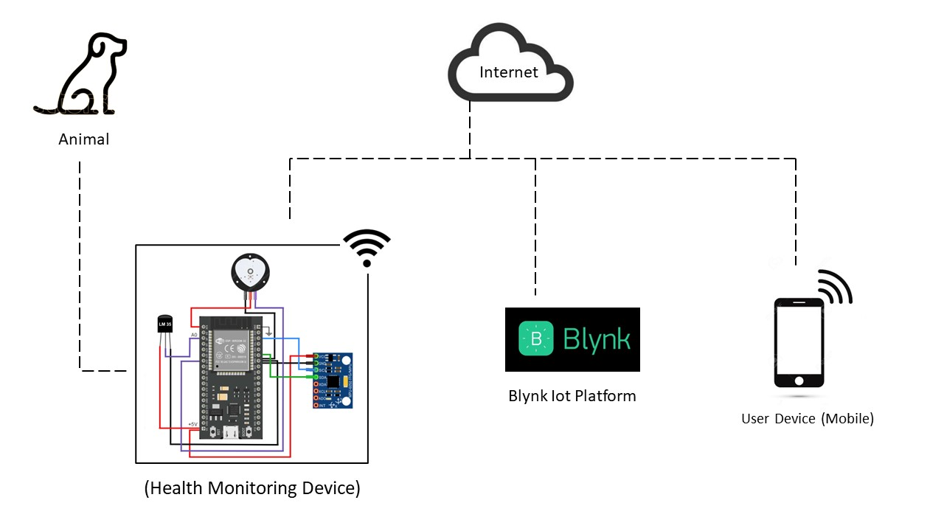

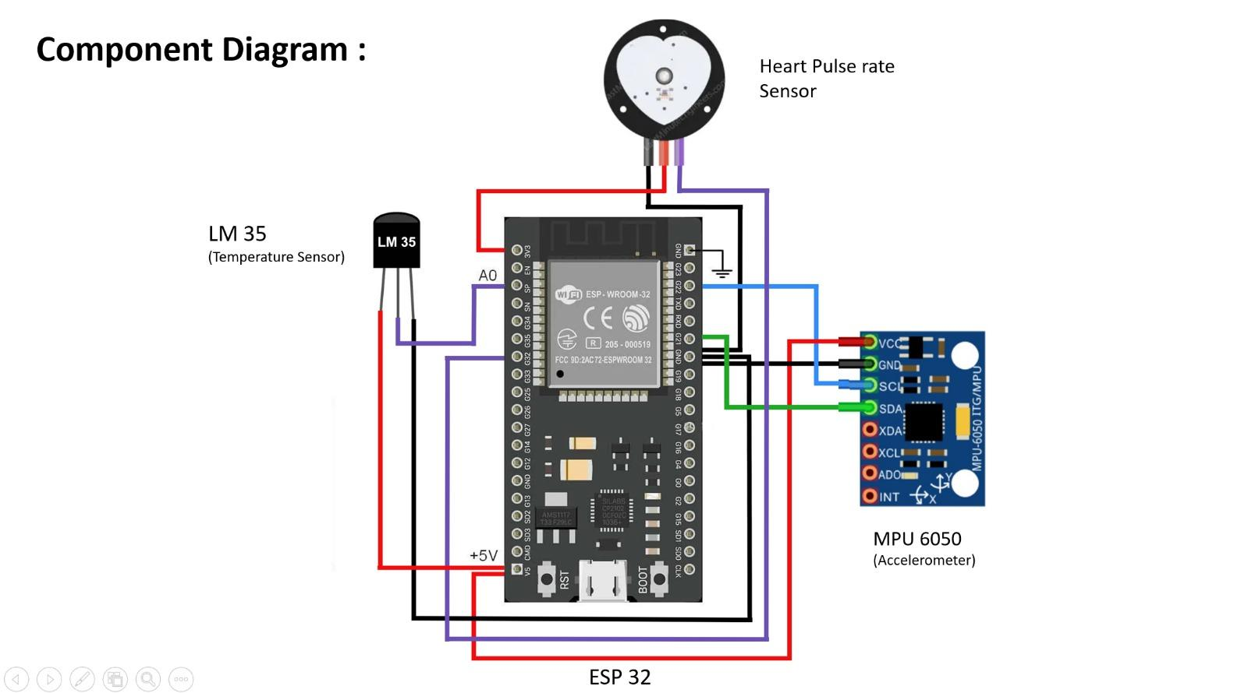

**2] Data Flow Diagram**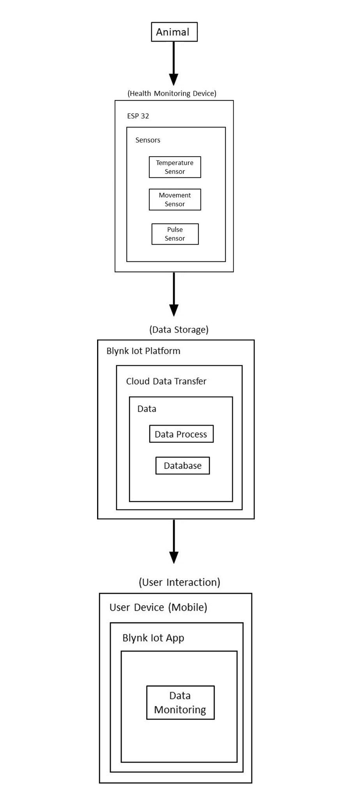

**3] SEQUENCE DIAGRAM**

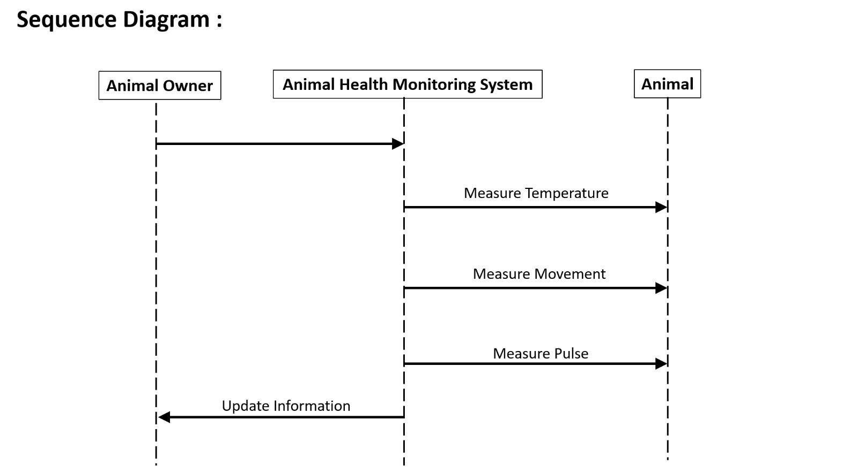

**4] ENTITY RELATIONSHIP DIAGRAM**

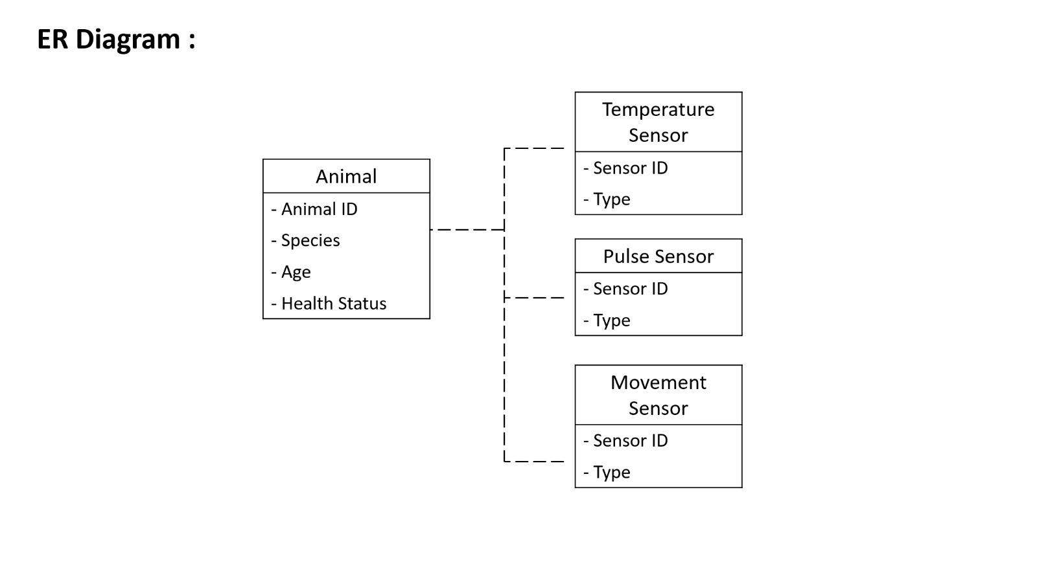

**5] UML DIAGRAM**

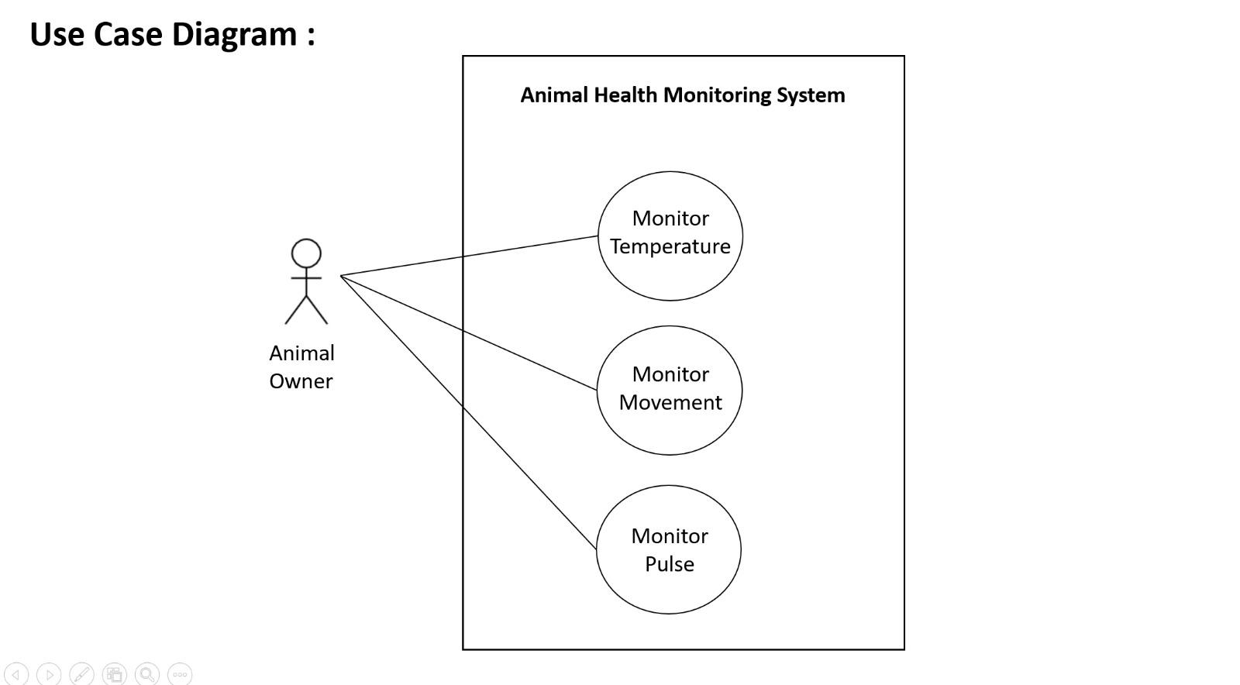

1. **PROJECT PLAN**

**5.1.1 PROJECT ESTIMATES**

**Reconciled Estimates:**

**Cost Estimates:**

Here's a breakdown of the estimated costs for the components mentioned in our project:

* LM35 Temperature Sensor:
  + Cost: 100/-
* Pulse Heart Rate Sensor:
  + Cost: 250/-
* 3D Accelerometer:
  + Cost: 150/-
* ESP32 Wroom WiFi-Bluetooth Module:
  + Cost: 400/-
* Bread Board:
  + Cost: 80-100/-

**Total Estimated Cost:**

* Minimum Estimate: 980/-
* Maximum Estimate: 1000/-

**TIME ESTIMATES:** Projected timelines for each phase and the overall project duration.

**(Gantt Chart)**

| **Task** | **Start Date** | **End Date** | **Duration** |
| --- | --- | --- | --- |
| **Project Initiation** | **2023-08-01** | **2023-08-07** | **1 week** |
| **Requirements Analysis** | **2023-08-08** | **2023-08-21** | **2 weeks** |
| **System Design** | **2023-08-22** | **2023-09-04** | **2 weeks** |
| **Hardware Procurement** | **2023-09-05** | **2023-09-18** | **2 weeks** |
| **Software Development** | **2023-09-19** | **2023-10-16** | **4 weeks** |
| **Testing and Debugging** | **2023-10-17** | **2023-11-06** | **3 weeks** |
| **Integration** | **2023-11-07** | **2023-11-20** | **2 weeks** |
| **User Training** | **2023-11-21** | **2023-12-04** | **2 weeks** |
| **Finalization and Launch** | **2023-12-05** | **2023-12-18** | **2 weeks** |

**5.1.2] PROJECT RESOURCES**

**1] LM35 Temperature Sensor:**

* Physical sensor units (as needed for each animal)
* Wiring and connectors for sensor placement
* Power source (battery or external power supply)

**2] Pulse Heart Rate Sensor:**

* Physical sensor units (as needed for each animal)
* Wiring and connectors for sensor placement
* Power source (battery or external power supply)

**3] 3D Accelerometer:**

* Physical sensor units (as needed for each animal)
* Wiring and connectors for sensor placement
* Power source (battery or external power supply)

**4] ESP32 Wroom WiFi-Bluetooth Module:**

* ESP32 Wroom WiFi-Bluetooth Modules
* Antennas (if not included in the modules)
* Wiring and connectors for module integration
* Power source (battery or external power supply)

5] **Bread Board:**

* Breadboards (as needed for prototyping)
* Jumper wires for connecting components on the breadboard
* External power supply (if needed)

6] **Facilities:**

* Office space for project coordination and development
* Workshop space for hardware testing and assembly

7] **External Services:**

* Vendor services for sensor procurement (if applicable)
* Cloud services for data storage and analysis

8] **Documentation:**

* Project plan and documentation
* User manuals for sensor integration and maintenance

9] **Communication Tools:**

* Communication tools such as email, messaging, and video conferencing for team collaboration.

10] **Software Tools:**

* Integrated Development Environment (IDE) for programming the ESP32 module
* Data analysis tools for interpreting sensor data

**5.2 RISK MANAGEMENT**

**5.2.1] RISK IDENTIFICATION:**

a. **Technical Risks:**

* Sensor Integration Issues: Challenges in integrating different sensors (LM35, Pulse Heart Rate Sensor, 3D Accelerometer) with the ESP32 module.
* Data Interference: Possible interference or data conflicts between multiple sensors.

b. **Operational Risks:**

* Power Source Reliability: Dependence on batteries, which may pose a risk if not monitored and replaced on time.
* Sensor Calibration: Inaccuracies due to improper calibration of sensors.

c. **Project Management Risks:**

* Resource Availability: Availability of skilled personnel for sensor integration and software development.
* Timeline Delays: Unforeseen delays in the development and testing phases.

d. **Security and Privacy Risks:**

* Data Security: Risks related to unauthorized access to sensitive data collected from livestock.
* Privacy Concerns: Concerns regarding the privacy of livestock owners and their data.

**5.2.2 Risk Analysis:**

a. **Probability and Impact Assessment:**

* Sensor Integration Issues: Moderate probability, high impact (could delay the entire project).
* Power Source Reliability: Low probability, medium impact (may lead to temporary data loss).
* Resource Availability: Medium probability, medium impact (may cause delays).
* Data Security: Low probability, high impact (serious consequences if compromised).

b. **Risk Prioritization**:

* High Priority: Sensor integration issues, data security.
* Medium Priority: Power source reliability, resource availability.
* Low Priority: Sensor calibration, timeline delays.

**5.2.3 OVERVIEW OF RISK MITIGATION, MONITORING, MANAGEMENT:**

a. **Risk Mitigation Strategies:**

* Diverse Power Sources: Implementing redundant power sources and regular monitoring to ensure continuous functionality.
* Robust Sensor Calibration: Rigorous testing and calibration procedures to minimize inaccuracies.
* Cross-Training Team Members: Ensuring that team members are trained in multiple areas to mitigate resource availability risks.
* Encryption and Access Controls: Implementing robust data security measures, including encryption and access controls.

b. **Monitoring and Control:**

* Regular Testing: Continuous testing and quality assurance to identify and address technical issues early.
* Project Tracking: Regular tracking of project timelines and milestones to identify potential delays.
* Security Audits: Periodic security audits to identify and address potential vulnerabilities.

c. **Risk Management:**

* Contingency Planning: Developing contingency plans for critical risks to minimize their impact.
* Communication Plan: Establishing a clear communication plan to keep all stakeholders informed of project progress and potential risks.
* Adaptability: Maintaining an adaptable project plan to accommodate unforeseen changes or delays.

**5.3] PROJECT SCHEDULE**

**5.3.1 Project Task Set**

* **Project Initiation (August 2023):**
  + Define project scope and objectives
  + Identify stakeholders
  + Form project team
* **Sensor Procurement and Testing (August 2023 - September 2023):**
  + Order LM35 Temperature Sensors, Pulse Heart Rate Sensors, and 3D Accelerometers
  + Test sensors for compatibility and accuracy
* **ESP32 Module Integration (September 2023):**
  + Acquire ESP32 Wroom WiFi-Bluetooth Modules
  + Integrate sensors with ESP32 modules
  + Conduct initial testing of the integrated system
* **Breadboard Prototyping (October 2023):**
  + Set up breadboards for circuit prototyping
  + Test and refine the circuit design
  + Ensure proper connectivity and functionality
* **Software Development (October 2023 - November 2023):**
  + Develop software for ESP32 module
  + Implement data collection and transmission logic
  + Test software integration with sensors
* **System Testing and Calibration (November 2023):**
  + Conduct comprehensive system testing
  + Calibrate sensors for accuracy
  + Address any identified issues or discrepancies
* **Security Implementation (November 2023):**
  + Implement data security measures
  + Conduct security testing and audits
* **Documentation and Training (December 2023):**
  + Create user manuals and documentation
  + Provide training for end-users and maintenance staff
* **Project Review and Finalization (December 2023):**
  + Review project deliverables against initial objectives
  + Make any necessary final adjustments
  + Prepare for project deployment

**5.3.2. TASK NETWORK**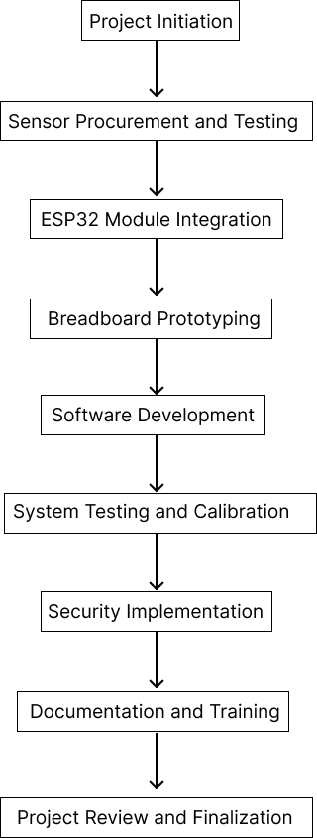

**5.3.3 TIMELINE CHART**

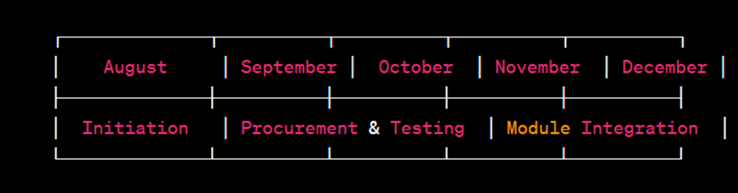

**5.4] TEAM ORGANISATION**

**5.4.1 Team structure:**

a. Sujitkumar Patil (Testing and Deploying )

b. Suraj Meshram (Requirement Gathering, Planning )

c. Sanskruti Jaiswal ( Documentation and Planning )

d. Kiran Musale (Planning and Testing )

**5.4.2 Management Reporting and Communication**

1. Daily Updates were taken for completion of given work to each member.

2. Discord Channel has been setted up for daily meetings and communication

1. **PROJECT IMPLEMENTATION**

The proposed animal health monitoring and tracking system, where each pet animal wears a specialized device on its collar, presents a comprehensive solution for continuous monitoring and enhanced well-being. This device, resembling a small computer with an enduring battery life, is equipped with tiny sensors that capture various aspects of the animal's behavior and movements. The incorporation of motion-detecting sensors enables the system to track the pet's activities, offering insights into its overall health and well-being.

The sensors within the device are not only capable of detecting the pet's movements but can also ascertain its orientation, providing a more nuanced understanding of the animal's behavior. For instance, monitoring the way a cow moves and faces can yield valuable information about its comfort, activity levels, and potential signs of distress. This data can be instrumental in early detection of health issues, allowing for timely intervention and care.

Furthermore, the device is designed for seamless wireless communication with other devices, forming a network that facilitates real-time data exchange. This wireless connectivity ensures that the information collected by the collar device can be efficiently transmitted to a centralized monitoring system. This central hub can be accessed by pet owners, veterinarians, or farm managers to monitor the health and behavior of individual animals or an entire herd.

The long-lasting battery incorporated into the device is a critical component, ensuring continuous monitoring without causing undue stress to the animals. This feature addresses a common concern in wearable technology — the need for sustained power without frequent recharging or replacement.

The capability of the device to take measurements from its sensors 5 times every second represents a remarkable advancement in real-time monitoring for animal health. This high-frequency data collection provides an unparalleled level of granularity, effectively allowing the device to keep a continuous and vigilant eye on the cow's activities. The rapid sampling rate of 5 times per second ensures that even the subtlest changes in the animal's behavior are captured and analyzed, offering a dynamic and detailed profile of its daily activities.

The constant stream of measurements enables the device to create a comprehensive record of the cow's movements and behaviors. For example, it can precisely track whether the cow is eating, walking, resting, or engaging in other activities. This level of insight is invaluable for farmers, veterinarians, and animal caregivers, as it facilitates a nuanced understanding of the animal's routine and can serve as an early indicator of any deviations from normal behavior.

The real-time nature of the measurements enhances the system's responsiveness, making it capable of quickly detecting changes in the cow's behavior. This can be particularly crucial for identifying signs of distress, illness, or abnormalities. By continuously monitoring the cow at such a high frequency, the device contributes to proactive healthcare management, allowing for timely interventions and ensuring the well-being of the animal.

Moreover, the frequent measurements contribute to the generation of dynamic behavioral patterns, enabling the system to adapt and learn from the cow's individual characteristics over time. This personalized approach enhances the system's predictive capabilities, making it more effective in anticipating and addressing the specific needs of each animal.

In summary, the proposed animal health monitoring and tracking system leveraging collar-mounted devices with motion-detecting sensors, wireless communication capabilities, and long-lasting batteries is poised to revolutionize the way we care for and understand the health of our pets. This technology not only offers a holistic view of the animals' activities but also provides a foundation for proactive and preventive healthcare management, ultimately contributing to the overall well-being and happiness of our cherished companions.

1. **RESULTS**

**OUTCOME / SCREENSHOTS**

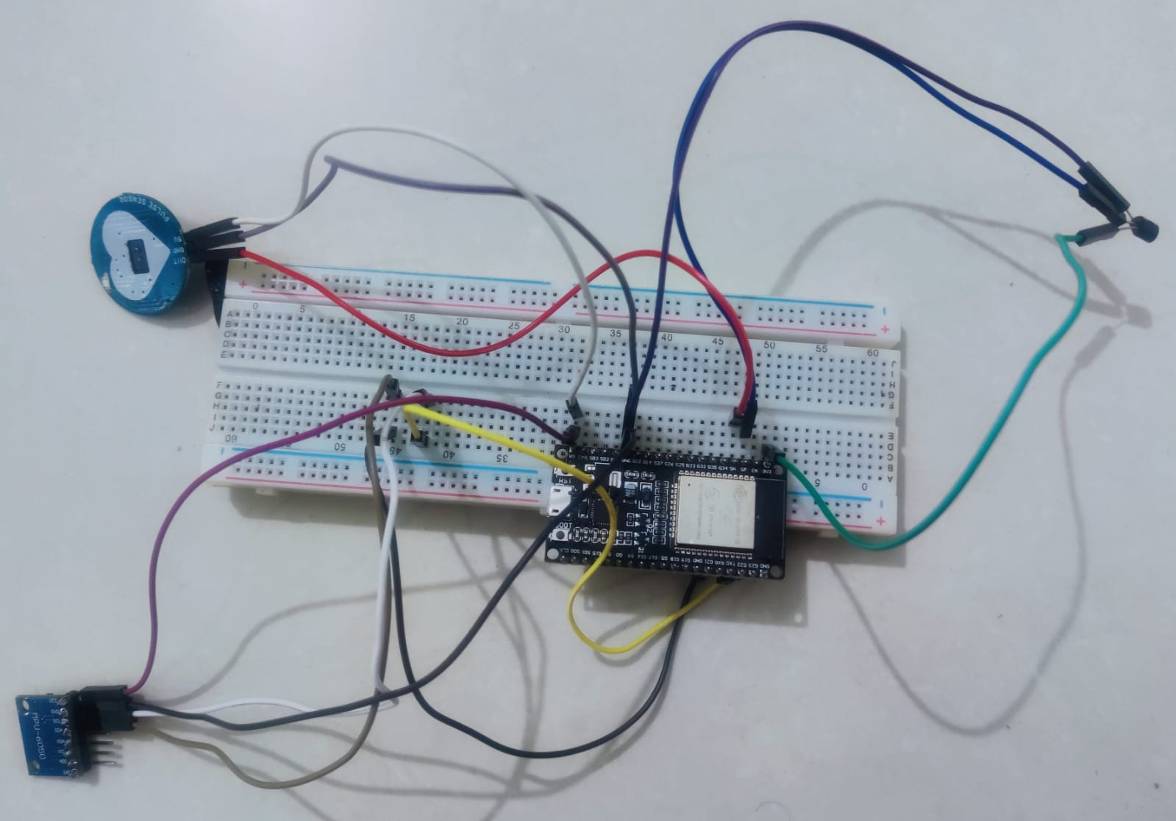

**Project Setup**

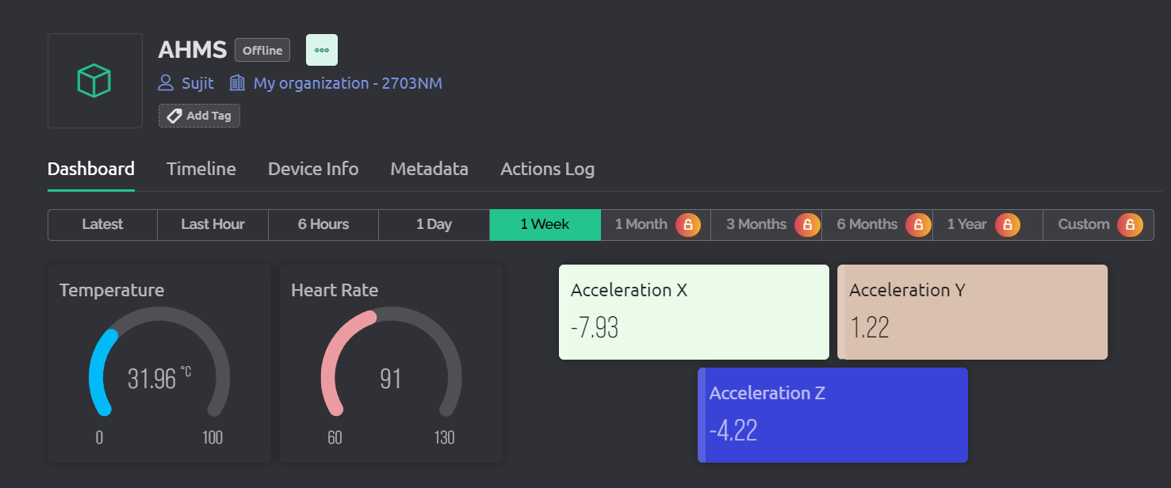

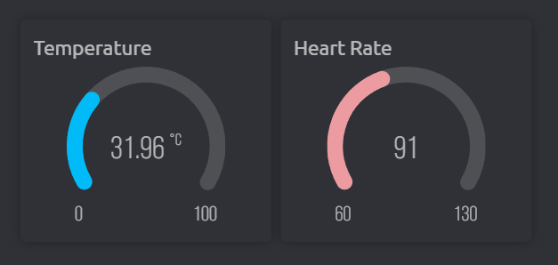

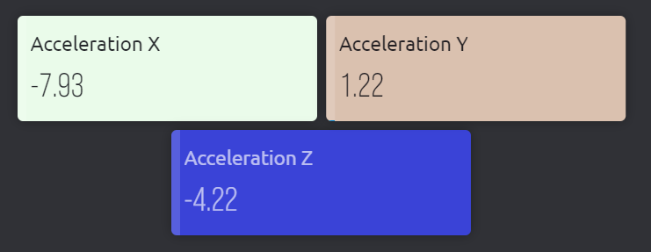

**Web Dashboard**

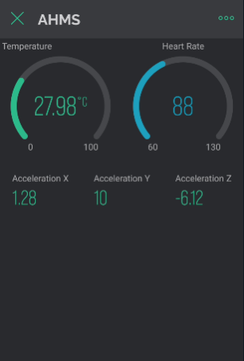

**Mobile Dashboard**

1. **CONCLUSION**

**Real-time Health Monitoring Through IoT:**

By seamlessly integrating IoT devices and sensors into this innovative system, a new era of pet healthcare emerges. This technological advancement facilitates real-time monitoring of crucial health indicators in cats and dogs, offering pet owners and veterinarians unprecedented insights into the well-being of their furry companions. The constant stream of data from these devices allows for the early detection of potential health issues, ensuring timely intervention and preventive care.

**Enhanced Adaptability and Accuracy Through IoT and Data Visualization:**

The incorporation of IoT technology goes beyond real-time monitoring, contributing to the system's continual improvement in adaptability and accuracy. Over time, the system learns and refines its understanding of individual pets' health patterns, enhancing its ability to detect subtle changes indicative of underlying diseases. The synergy between IoT and data visualization transforms complex health data into comprehensible insights, providing a dynamic and visual representation of the pet's health status. This not only assists in early detection but also empowers pet owners to actively participate in their pets' well-being.

**Collaboration for Proactive Pet Healthcare:**

As we embark on the implementation journey, collaboration among stakeholders emerges as a pivotal factor for success. Pet owners, veterinarians, and technology developers must work in tandem to ensure the seamless integration and effective utilization of this initiative. This collaborative effort aims to foster a paradigm shift in pet healthcare, moving towards a proactive and efficient model of disease management. By leveraging technology and shared expertise, this system seeks to elevate the standard of care for pets, emphasizing preventive measures and early intervention to enhance their overall quality of life.

Looking forward, this research paves the way for advancements in the field of animal care and agriculture. The continuous and real-time nature of data collection, coupled with the potential integration of artificial intelligence and machine learning, positions these systems at the forefront of scientific research. The data generated can contribute not only to individual farm management but also to broader studies on animal behavior, health patterns, and disease dynamics, furthering our understanding and refining our approach to agriculture.

In essence, the marriage of IoT technology with animal health monitoring represents a synergy between innovation and compassion. By addressing the concerns, harnessing the benefits, and embracing a future-oriented mindset, we can collectively work towards an agriculture landscape where technology and empathy converge to ensure the well-being of both livestock and farmers, setting the stage for a sustainable and progressive future in agriculture.

**8.3. FUTURE WORK**

Here are potential areas for future work and advancements in the IoT-based animal health monitoring system:

**Enhanced Sensor Capabilities:**

* Future work could focus on the development and integration of more advanced sensors to expand the range of health parameters monitored. This could include sensors for additional physiological indicators, such as respiratory rate, hydration levels, or specific biomarkers, providing a more comprehensive health assessment for animals.

**Predictive Analytics and AI Integration:**

* Incorporating predictive analytics and artificial intelligence (AI) algorithms into the system can elevate its capabilities. By analyzing historical data patterns and correlating them with health outcomes, the system could predict potential health issues or trends, enabling even earlier intervention and personalized healthcare plans for individual animals.

**Wearable Technology Innovation:**

* Future developments may involve exploring new forms of wearable technology beyond traditional neckbands. This could include advancements in miniaturized, non-intrusive wearables or even implantable devices that offer continuous monitoring with minimal disruption to the animals' behavior.

**Edge Computing for Real-time Processing:**

* Implementing edge computing technologies could enable real-time processing of data directly on the monitoring devices. This reduces the reliance on centralized processing, allowing for quicker response times and minimizing the need for constant high-bandwidth communication with the central system.

**Environmental Monitoring Integration:**

* Extending the system to include environmental monitoring can provide valuable contextual information. Factors such as ambient temperature, humidity, or air quality can impact animal health. Integrating these data points could enhance the system's ability to correlate environmental factors with health outcomes.

**User Feedback and Iterative Design:**

* Continuous user feedback and iterative design processes should be embraced for system refinement. Gathering insights from pet owners, veterinarians, and other stakeholders will help identify areas for improvement, usability enhancements, and the introduction of features that align more closely with user needs and preferences.

These future directions aim to push the boundaries of IoT-based animal health monitoring, fostering innovation and improvements in both technology and methodology for the benefit of animals and their caregivers.

**REFERENCES**

[1] The future of food and agriculture: Trends and challenges. Food and Agriculture Organization of the United Nations (2015).

[2] Rakesh, M. J. India’s Dairy Exports: Opportunities, Challenges and Strategy. Indian Food Packer-Bi-monthly J. All India Food Process. Assoc. 63, 36–49 (2009).

[3] Siddiky, M. Dairying in South Asian region: opportunities, challenges and way forward. SAARC J. Agric. 15, 173–187 (2017).

[4] Shanafelt, D. W. & Perrings, C. The Effect of the Post 2001 Reforms on FMD Risks of the International Live Animal Trade. Ecohealth 15, 327–337 (2018).

[5] Department of Agriculture, U. S. Veterinary Services Foot-and-Mouth Disease. 1–2 (2013).

[6] TIWARI, M., MAHAJAN, R., AHUJA, S., RAWAT, S., & MITTAL, V. Fuzzy

Keyword Search Over Encrypted Data in Cloud Computing. vol, 4, 15-20.

[7] RAMAO, R. (2015) The Importance of a Standard Security Architecture for SOA-based

IoT Middleware. IEEE COMMUNICATIONS MAGAZINE, 1(1), p. 1-10.

[8] RAED, A. ADEN, A. Maythem K., “Electronic Toll Collection System based on Radio

Frequency Identification System,”. International Journal of Electrical & Computer

Engineering, pp.2088-8708, 1;8(3), 2018.

[9] Sherasiya, T., Upadhyay, H., & Patel, H. B. (2016). A survey: Intrusion detection system

for internet of things. International Journal of Computer Science and Engineering

(IJCSE), 5(2).

[10] RAED, A. Widad, I., “Active RFID System with Embedded Wireless Sensor Network

for Reliable Data Communication,”. In Technological Breakthroughs in Modern Wireless

Sensor Applications, IGI Global, pp. 83-108, 2015.

[11] Kushwah, A., Rudrappa, S., & Shukla, P. Relative Changes in Blood Biochemistry of

Spitz Dog under Variable Ill Health States.